Victoria Chung  
Dr. Pollitte

MKTG-6322-02

October 22, 2021

Fall 2021

**I: Simple Analyses with Categorical Data**

**Frequencies**Since Mode is 4, that means most people live in the Midwest and least are in Southeast. Frequencies look good. There are no missing variables.   


**Bar Chart**

The Bar graph shows that the Midwest as the largest region and Southeast is the smallest.

**Crosstabs**

Since the Chi-Square is .247 it is greater than .05, therefore there is no difference between male and female responses. There are 275 females and 725 males. The percentages are 87.2% males and 84.4% females which tells us the values are not as significantly far enough apart from each other as indicated by the chi-squared .247. They predominantly responded No.  
  
The percentage responders who are female and male below we have 27.5% who are female and 72.5% who are male.   
  
**II: Simple Analyses with Continuous Data**

**Descriptives**

There is 1000 people, minimum purchase 1 with 15 purchases being the maximum, with a total of 1,822 purchases mad and an average of 1.82 purchase per person. The minimum total spent was $50, with a maximum spent of $8,763, overall sum from is $335,229 with an average of $335.23 spent per person.

**Histograms**The peak looks to be around 37.76. Looks like a normal distribution.

**Correlations**

There is less than .05 at .001 so it’s correlated. It’s a positive and strong correlation by looking at .857 since it’s between ±07 to ±1.0. Since it is a positive correlation, it means since the total dollar spent goes up the number purchases also go up too. They move up together.

**III: Simple Analyses with both Continuous and Categorical Data**

**Histograms for subcategories**

Male and female skewed to the right, the difference is there is more male than female. With the male histogram there is a lot of males that purchased 1 with the max being 9. The females are similar, there is a difference in mean by .03, but the standard deviation is almost exact.

**Descriptives statistics for subcategories**

Tells you people in the Midwest has the highest number and percentage. The Northeast has the largest average dollar spent at $380.74. Midwest spent the largest sum at $93,996.

**Graphing the relationship between two variables**12 has the largest number of purchases and the total dollars spent is above $8,000 for all the people that made the 12 purchases.

**IV: Data Manipulation – Creating New Variables**

**Computing a new variable**

The new variable tells us what the average dollar spent per customer is. We are dividing by the total dollars by the number of purchases. From the 1000 people, the minimun spent is $14, max is $1,095.38 and the average is $126.68 per person.

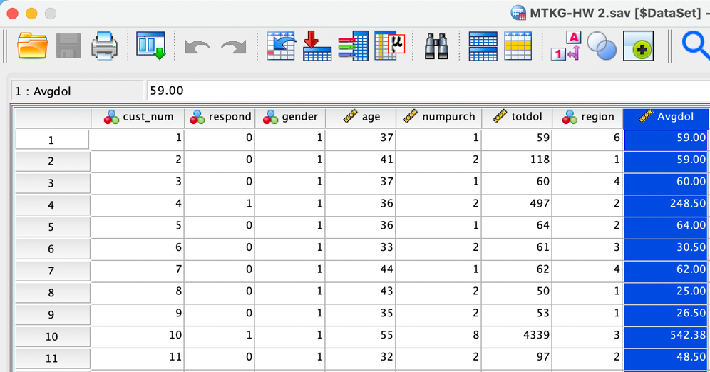

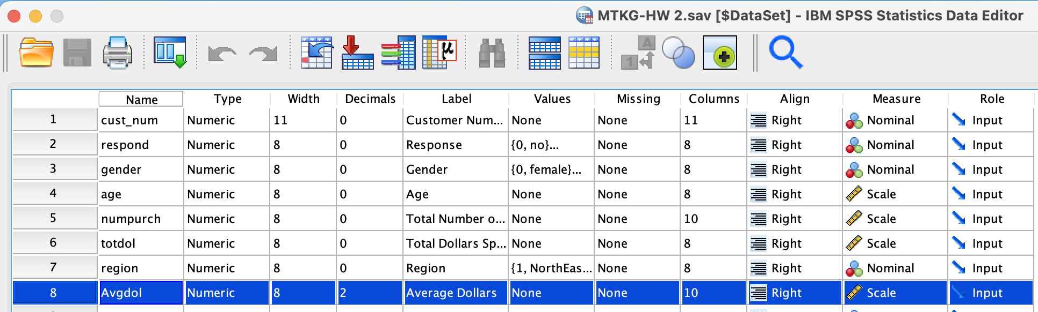

**Recording a variable into a new variable**

New column tells us whether they are a repeat customer (bought 2+). Anyone who bought 1 and below will be labeled no. By using the crosstabs to see whether the repeat and non-repeat customers responded we could see that 463 of the customers who were not repeat customers responded no at 46.3% and 62 of the non-repeat customers responded yes at 6.2%. Out of the repeated customers, 401 responded No at 40.1% and 74 of the repeat customers responded yes at 7.4%.

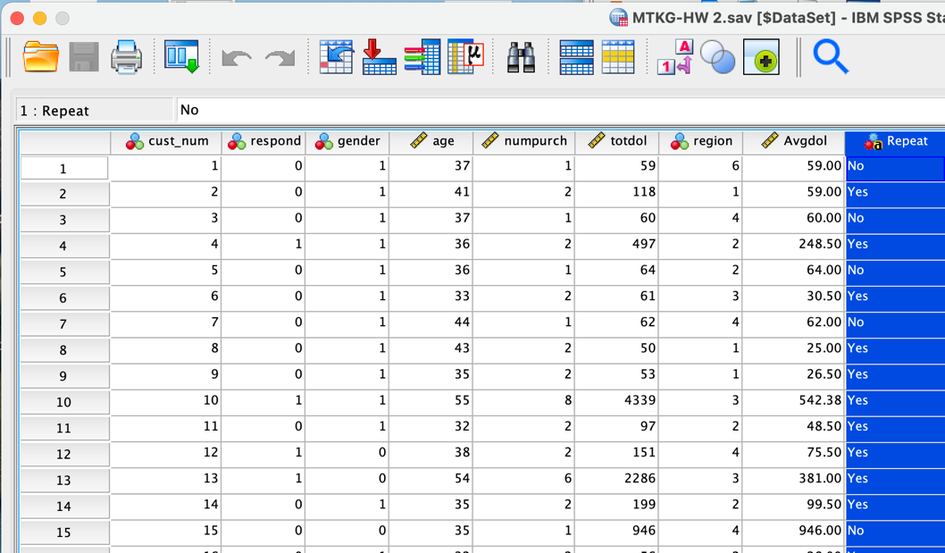

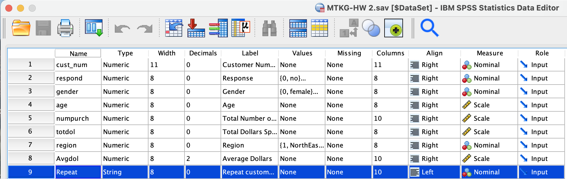

**Generating a decile or quintile variable**

Rank the total number of dollars into 5 groups to create a new variable. The 1000 people were roughly split in groups of 200, 20% put in 5 groups in roughly equal sizes. They are not exact equal but are pretty close.

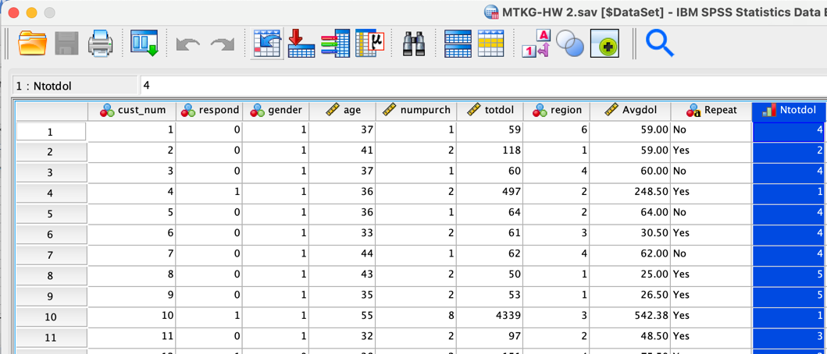

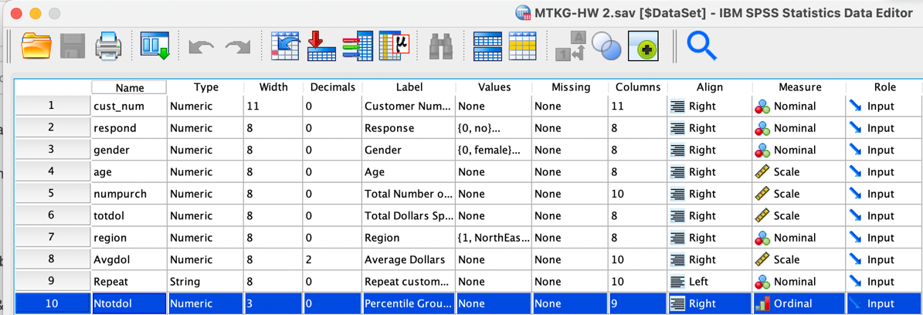

**VI: Selecting Records from a Dataset**Out of the 227 people from the Northeast region, the minimum purchase is 1, maximum purchase is 10, and the average of purchases per person is 1.98. The minimum dollar spent is $50, the maximum is $8,763, and the average dollar spent per person is $380.74.

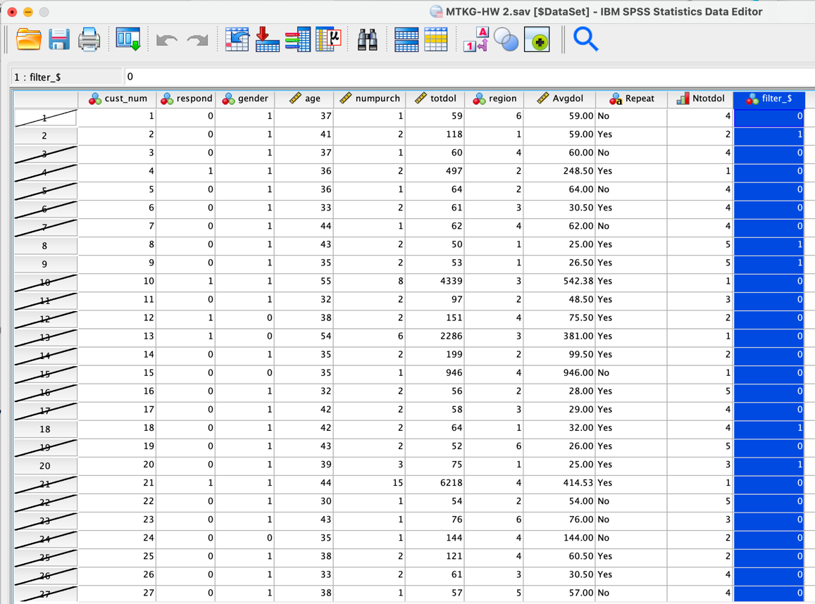

After completing all the analysis, please answer the following three questions regarding the overall analysis:

**A. What would the results you see mean to you as a marketing manager?**From observation, it looks like the results look good. They are positive, people in the Northeast and Midwest are good regions to market to and sell product since they spend the most and purchase the most. To put in more marketing dollars in those two regions and focus my attention on nurturing the repeat customers and increasing the percentage.

**B. Are there opportunities for growth?**

I think there are opportunities for growth because the correlation is positive and strong, there were no missing variables, and the data tells me that when the dollar amount increases that the purchases also increase. There is a good number of repeat customers as there are non-repeat customers. With a 7.4% of repeat customers responding I think that seems promising especially if it is coming from a region with more dollars spent.

**C. Should there be more analysis?**

I think there could always be more analysis, but it depends on what you would like to measure for. We can measure the total number of purchases by region, or the total dollar spent by age. For this specific analysis, regardless of which variables we want to continue measuring, I think our results will come out similar where Northeast and Midwest will come out on top with positive and strong correlations which is probably all we really need to know.